Author: Ndiouga Benga
Senghor, Léopold Sédar (b. 1906 Joal, Senegal – d. 2001 Verson, France)
Poet, politician, and cultural theorist, Léopold Sédar Senghor was the first president of Senegal from 1960 to 1980. His devotion to the arts as a critic, aesthete and patron developed during the inter-war period in the formation of the concept of Négritude along with Aimé Césaire and Léon Damas. Senghor designed and built everything, according to the understanding of Négritude as African authenticity independent from Western art conventions, as a claim of black identity and the cornerstones of which are rootedness and openness which inspire his aesthetic. He proposed an effort to prospective thinking, guided by the movement. The aim was to transmit to young generations the values ​​of Négritude, through the introduction of modern technology. ‘The Priority of Development should not detract from the Primacy of Culture, as a contribution to the Civilization of the Universal which is an integral humanism, a horizon and a purpose, which nurtures and develops both body and soul’ he wrote. It was in the very essence of the policy of Senegal to defend the values ​​of black civilization and to be the spearhead of young African States in terms of education, culture and training. Therefore Senghor spent more than thirty percent of the national budget on these sectors in the 1960s.
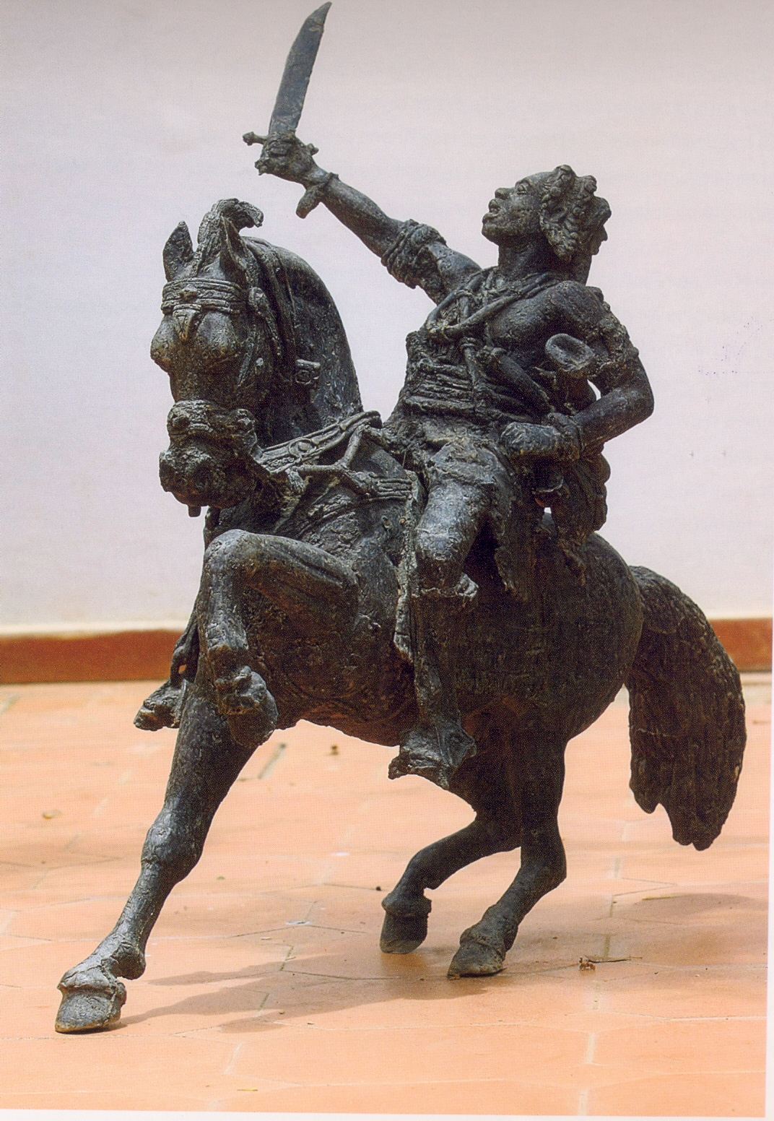
Senghor embarked on an extensive program of cultural infrastructures (School of Arts, Theatre Sorano, Musée Dynamique, Stade de l’Amitié, Cultural Archives, Centre for Civilizations Studies, Université des Mutants de Gorée, Léopold Sedar Senghor Foundation...) and global events (World Festival of Black Arts, Marc Chagall, Pablo Picasso, Pierre Soulages, Alfred Manessier, Iba Ndiaye, André Masson exhibitions in Dakar, Senegalese Arts Salon and cultural weeks abroad), which allowed the confrontation, the dissemination and the synthesis of Black Arts worldwide. It was essential to place Dakar as a pole of cultural Pan-Africanism and African integration. The aesthetic of the rhythm and the asymmetric parallelism printed a specific direction to the École de Dakar in which triumphed the theories and ideas of Senghor who oriented the bases of creation by direct and regular interventions with artists. In the time of his omnipotence, the majority of the creators in visual arts were inspired by or took into account his remarks, resulting in the marginalisation of artists who challenged the themes and practices of this art of "undeniable Africanness" such as the filmmaker Ousmane Sembène, Laboratoire Agit' Art, and Front Culturel.

Cheikh Makhone Diop, Lat Dior on Malaw, bronze carving, in Sylla, A., Seck, S. and Mbaye, M. (eds.) (unknown date) Une passion en couleurs. Art contemporain du Sénégal, collection de Abdoulaye Diop et de Fatoumata Sow, Dakar: Imprimerie du Midi, p. 48.
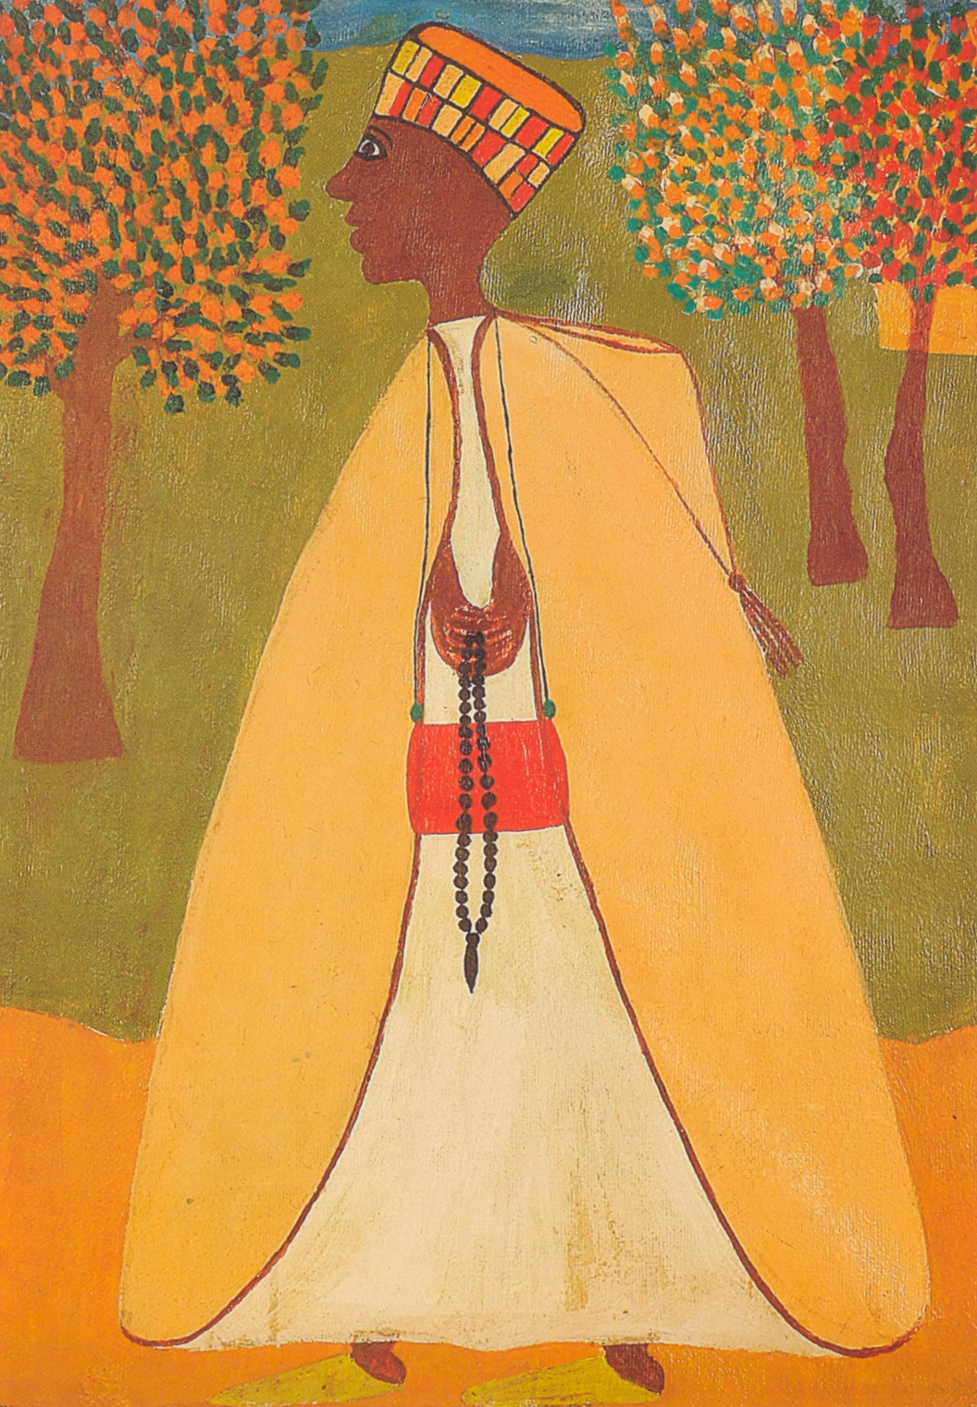

Mbor Faye, Portraiture of a Marabout, 1973, oil on canvas, in Sylla, A., Seck, S. and Mbaye, M. (eds.) (unknown date) Une passion en couleurs. Art contemporain du Sénégal, collection de Abdoulaye Diop et de Fatoumata Sow, Dakar: Imprimerie du Midi, p. 52.

Selected list of works

Senghor, L. S. (1964) Liberté I: Négritude et Humanisme, Paris: Seuil.

Senghor, L. S. (1977) Liberté III: Négritude et Civilisation de l’Universel, Paris: Seuil

Senghor, L. S. (1993) Liberté V: Le dialogue des cultures, Paris: Seuil

References and further reading

Bidima, J.-G. (1997) L’art négro-africain, Paris: PUF.

Diagne, S. B. (2007) Léopold Sedar Senghor : l’art africain comme philosophie, Paris: Riveneuve.

Spivak, G. C. (1990) The Postcolonial Critic. Interviews, Strategies, Dialogues, New York and London: Routledge

Sylla, A. (2006) L’esthétique de Senghor. Essai, Dakar: Les Editions Feu de brousse.

Sylla, A., Seck, S. and Mbaye, M. (eds.) (unknown date) Une passion en couleurs. Art contemporain du Sénégal, collection de Abdoulaye Diop et de Fatoumata Sow, Dakar: Imprimerie du Midi

Vaillant, J. (1990) Black, French and African. A Life of Léopold Sedar Senghor, London –Cambridge: Harvard University Press.

